ITA0305- Mobile Computing
LAB EXPERIMENT
Name: G.Ganesh
Reg NO:192373008

21. Implement a live chart to monitor network throughput.
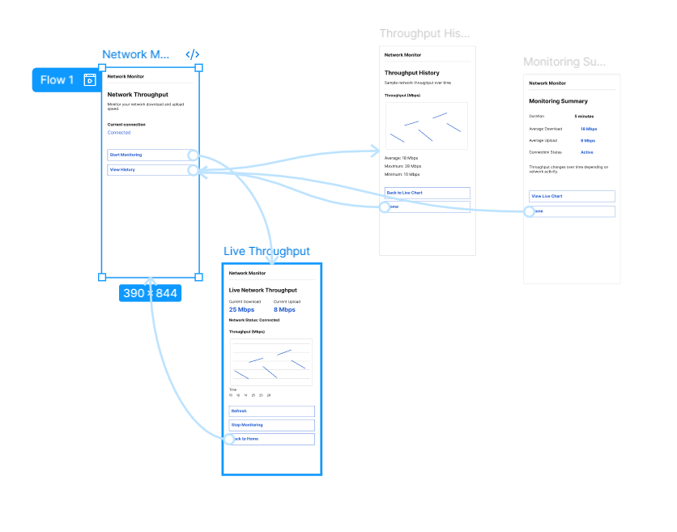
https://www.figma.com/design/ptL1gbbVldIh4M4sme7L2E/program21?node-id=18-137&t=4rxI6qgKoUxDsPtA-0

